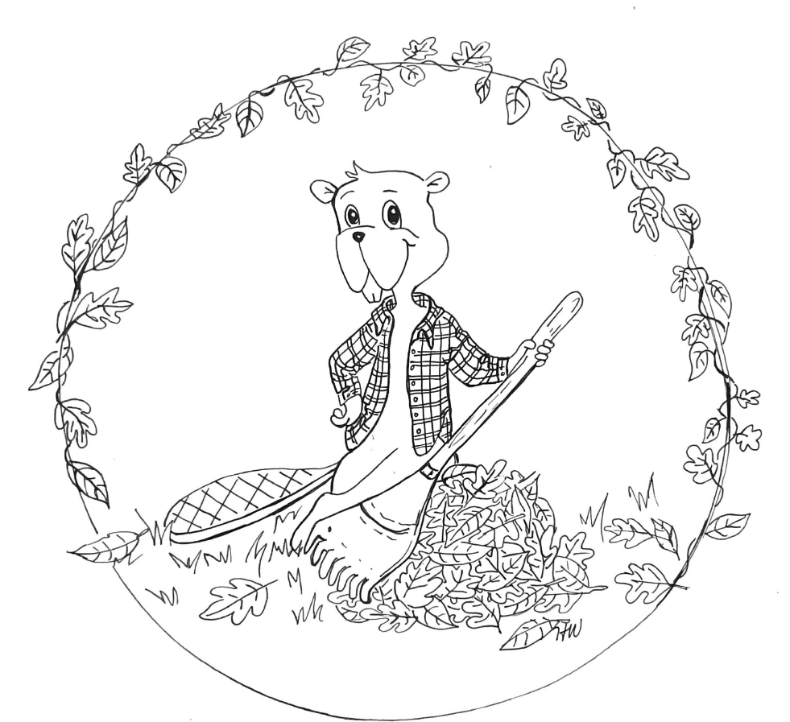

Name: age:

Color and return to Children’s Dental Care by Thursday, November 21, 2024. Winners will be chosen on November 25, 2024.

***113 Railroad St. Keene, NH 03431 • P: 603-357-6385 •*** [***www.drwully.com***](http://www.drwully.com) ***• Follow us @drwully • Email: marketing@drwully.com***